Functional Model
Community Textile Recovery System
By
Lakshmi Bindu Bandari

1. Use Case Diagram
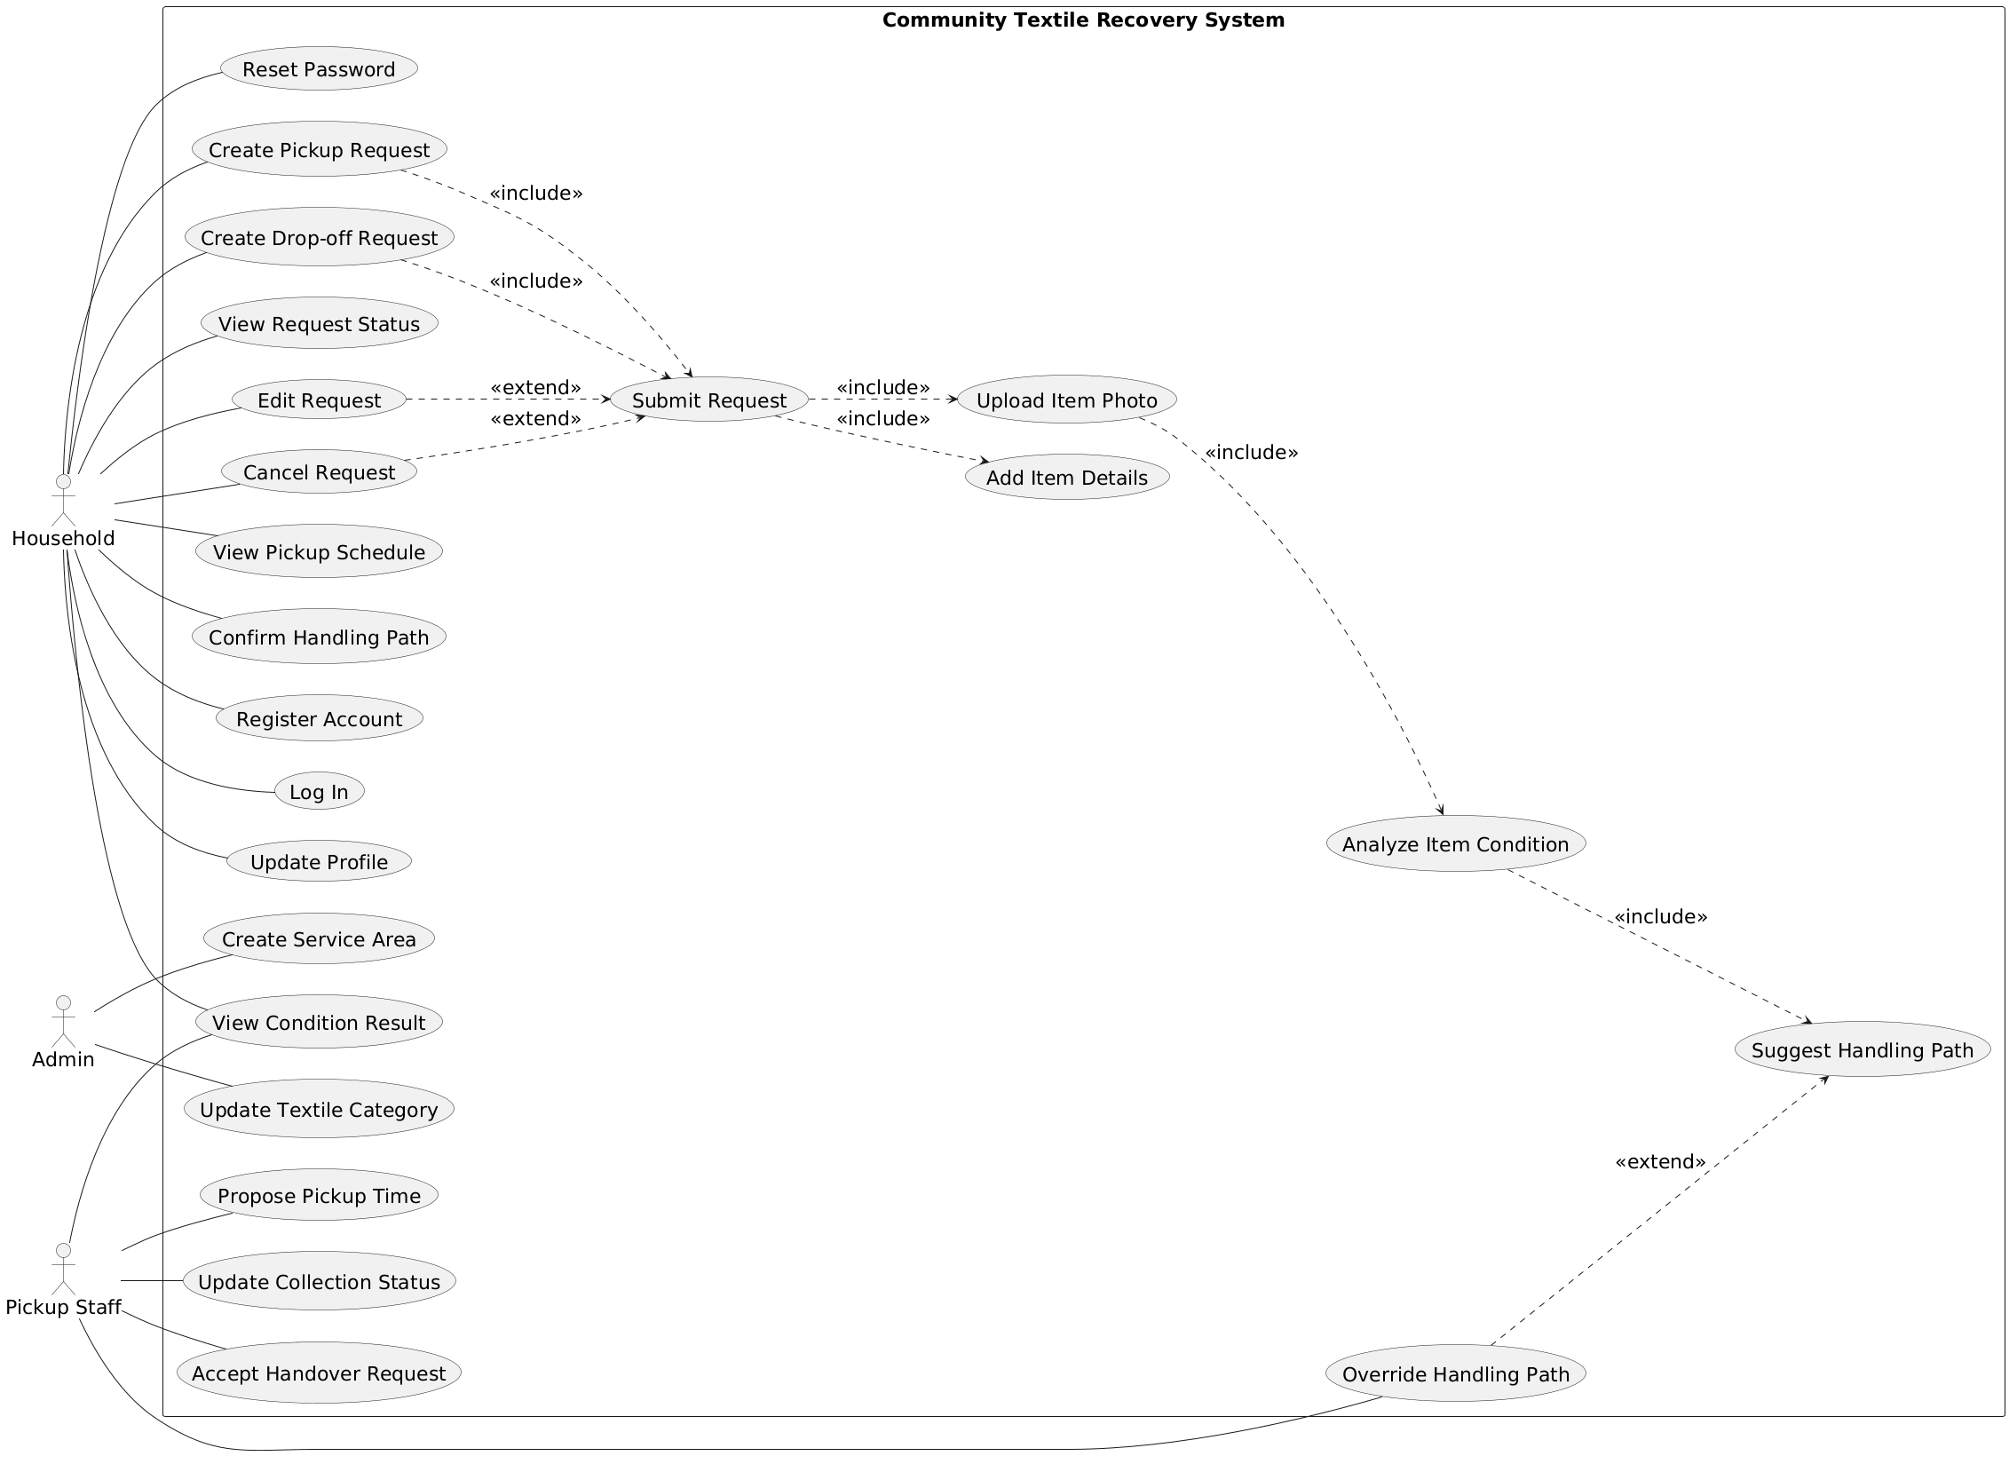
Figure.1 Use Case Diagram

2. Use Case Description

Use Case 1
Use Case Number | 1
Use Case Name | Register Account
Primary Actor | Household
Supporting Actors | System
User Requirement Reference | 1
Trigger | Household selects the register option
Pre-Conditions | User does not have an account
Post-Conditions | New user account is created
Normal Flow | 1. Household opens the registration page.  2. Household enters email and password.  3. System validates the input.  4. System stores the user profile.  5. System confirms successful registration.
Exception Flows | 1a. Email already registered → system shows an error message.  2a. Invalid input → system requests correction.

Use Case 2
Use Case Number | 2
Use Case Name | Log In
Primary Actor | Household
Supporting Actors | System
User Requirement Reference | 2
Trigger | Household selects login
Pre-Conditions | User account exists
Post-Conditions | User is logged into the system
Normal Flow | 1. Household enters email and password.  2. System validates credentials.  3. System grants access to the dashboard.
Exception Flows | 1a. Incorrect credentials → system shows error message.  2a. Account locked → system blocks login.

Use Case 3
Use Case Number | 3
Use Case Name | Reset Password
Primary Actor | Household
Supporting Actors | System
User Requirement Reference | 5
Trigger | Household selects forgot password
Pre-Conditions | User account exists
Post-Conditions | Password is updated
Normal Flow | 1. Household enters registered email address.  2. System sends password reset link.  3. Household opens link and enters new password.  4. System updates the password and confirms success.
Exception Flows | 1a. Email not found → system displays message.  2a. Reset link expired → system requests a new reset request.

Use Case 4
Use Case Number | 4
Use Case Name | Update Profile
Primary Actor | Household
Supporting Actors | System
User Requirement Reference | 4
Trigger | Household selects edit profile
Pre-Conditions | User is logged in
Post-Conditions | Profile details are updated
Normal Flow | 1. Household opens profile page.  2. Household edits personal details.  3. System validates updated information.  4. System saves changes.  5. System confirms profile update.
Exception Flows | 1a. Invalid input → system displays validation message.  2a. Save fails → system shows error and requests retry.

Use Case 5
Use Case Number | 5
Use Case Name | Create Pickup Request
Primary Actor | Household
Supporting Actors | System
User Requirement Reference | 6
Trigger | Household selects create pickup request
Pre-Conditions | User is logged in
Post-Conditions | Pickup request is created
Normal Flow | 1. Household opens pickup request form.  2. Household selects pickup option.  3. System prompts for item details and photos.  4. Household completes request details.  5. System creates a pickup request.
Exception Flows | 1a. Required details missing → system requests completion.  2a. System error → request is not saved.

Use Case 6
Use Case Number | 6
Use Case Name | Create Drop-off Request
Primary Actor | Household
Supporting Actors | System
User Requirement Reference | 7
Trigger | Household selects create drop-off request
Pre-Conditions | User is logged in
Post-Conditions | Drop-off request is created
Normal Flow | 1. Household opens drop-off request form.  2. Household selects drop-off option.  3. System prompts for item details and photos.  4. Household completes request details.  5. System creates a drop-off request.
Exception Flows | 1a. Missing details → system asks user to complete form.  2a. Save failure → system shows error message.

Use Case 7
Use Case Number | 7
Use Case Name | Submit Request
Primary Actor | Household
Supporting Actors | System
User Requirement Reference | 12
Trigger | Household clicks submit request
Pre-Conditions | Pickup or drop-off request form is completed
Post-Conditions | Request is submitted for processing
Normal Flow | 1. Household reviews request details.  2. Household confirms submission.  3. System validates request information.  4. System stores the request in database.  5. System marks request as pending.
Exception Flows | 1a. Validation fails → system shows error.  2a. Database error → system notifies failure.

Use Case 8
Use Case Number | 8
Use Case Name | Add Item Details
Primary Actor | Household
Supporting Actors | System
User Requirement Reference | 8, 9, 11
Trigger | Household adds item information
Pre-Conditions | User is creating a pickup or drop-off request
Post-Conditions | Item details are attached to the request
Normal Flow | 1. Household enters item type.  2. Household enters quantity and notes.  3. System validates item data.  4. System stores item details with the request.
Exception Flows | 1a. Invalid quantity → system shows validation message.  2a. Missing item type → system requests correction.

Use Case 9
Use Case Number | 9
Use Case Name | Upload Item Photo
Primary Actor | Household
Supporting Actors | System
User Requirement Reference | 10
Trigger | Household selects upload photo
Pre-Conditions | User is creating or editing a request
Post-Conditions | Item photo is uploaded and stored
Normal Flow | 1. Household selects image file.  2. System uploads photo.  3. System validates file format.  4. System stores photo with item record.
Exception Flows | 1a. Unsupported file type → system rejects upload.  2a. Upload failure → system displays error message.

Use Case 10
Use Case Number | 10
Use Case Name | Analyze Item Condition
Primary Actor | System
Supporting Actors | Household
User Requirement Reference | 16
Trigger | Photo is successfully uploaded
Pre-Conditions | Item photo exists
Post-Conditions | Condition result is generated
Normal Flow | 1. System sends image to CNN model.  2. Model analyzes condition.  3. System receives condition result.  4. System stores result with item record.
Exception Flows | 1a. Model service unavailable → system marks analysis pending.  2a. Invalid image → system requests new upload.

Use Case 11
Use Case Number | 11
Use Case Name | Suggest Handling Path
Primary Actor | System
Supporting Actors | Household, Pickup Staff
User Requirement Reference | 17
Trigger | Item condition result is generated
Pre-Conditions | Item condition has been analyzed
Post-Conditions | Handling path suggestion is available
Normal Flow | 1. System maps condition to reuse, repair, or recycle.  2. System displays suggested handling path.  3. System stores suggested path with the request.
Exception Flows | 1a. Mapping rule missing → system marks suggestion as unavailable.  2a. Processing error → system logs error and retries.

Use Case 12
Use Case Number | 12
Use Case Name | View Request Status
Primary Actor | Household
Supporting Actors | System
User Requirement Reference | 13
Trigger | Household opens request status page
Pre-Conditions | User is logged in and has submitted requests
Post-Conditions | Current status of requests is displayed
Normal Flow | 1. Household navigates to request list.  2. System retrieves request statuses.  3. System displays current status for each request.
Exception Flows | 1a. No requests found → system shows empty list message.  2a. Retrieval error → system displays error message.

Use Case 13
Use Case Number | 13
Use Case Name | Edit Request
Primary Actor | Household
Supporting Actors | System
User Requirement Reference | 14
Trigger | Household selects edit on a pending request
Pre-Conditions | Request exists and is not yet accepted
Post-Conditions | Request details are updated
Normal Flow | 1. Household opens request details.  2. Household modifies item or schedule details.  3. System validates updated information.  4. System saves changes and updates request.
Exception Flows | 1a. Request already accepted → system blocks editing.  2a. Validation fails → system requests correction.

Use Case 14
Use Case Number | 14
Use Case Name | Cancel Request
Primary Actor | Household
Supporting Actors | System
User Requirement Reference | 15
Trigger | Household selects cancel request
Pre-Conditions | Request exists and pickup time is not passed
Post-Conditions | Request is cancelled
Normal Flow | 1. Household selects cancel option.  2. System asks for confirmation.  3. Household confirms cancellation.  4. System updates request status to cancelled.
Exception Flows | 1a. Pickup time already passed → system blocks cancellation.  2a. System error → cancellation fails.

Use Case 15
Use Case Number | 15
Use Case Name | View Pickup Schedule
Primary Actor | Household
Supporting Actors | System
User Requirement Reference | 16
Trigger | Household opens pickup schedule
Pre-Conditions | User has an accepted pickup request
Post-Conditions | Pickup date and time are displayed
Normal Flow | 1. Household opens schedule view.  2. System retrieves pickup details.  3. System displays pickup date and time.
Exception Flows | 1a. No pickup scheduled → system displays message.  2a. Retrieval failure → system shows error.

Use Case 16
Use Case Number | 16
Use Case Name | Confirm Handling Path
Primary Actor | Household
Supporting Actors | System
User Requirement Reference | 18
Trigger | Household views suggested handling path
Pre-Conditions | Handling path suggestion is available
Post-Conditions | Handling path is confirmed
Normal Flow | 1. Household reviews suggested handling path.  2. Household confirms the suggestion.  3. System records confirmation for the request.
Exception Flows | 1a. Household disagrees → system allows note entry.  2a. System error → confirmation fails.

Use Case 17
Use Case Number | 17
Use Case Name | Accept Handover Request
Primary Actor | Pickup Staff
Supporting Actors | System
User Requirement Reference | 22
Trigger | Pickup staff selects a pending request
Pre-Conditions | Staff is logged in and request is available
Post-Conditions | Request is accepted
Normal Flow | 1. Staff views open requests.  2. Staff selects a request.  3. Staff accepts the request.  4. System updates status to accepted.
Exception Flows | 1a. Request already accepted → system blocks action.  2a. Update failure → system shows error message.

Use Case 18
Use Case Number | 18
Use Case Name | Propose Pickup Time
Primary Actor | Pickup Staff
Supporting Actors | System
User Requirement Reference | 23
Trigger | Pickup staff selects propose pickup time
Pre-Conditions | Request is accepted by pickup staff
Post-Conditions | Proposed pickup time is recorded
Normal Flow | 1. Pickup staff opens accepted request.  2. Pickup staff selects available date and time.  3. System validates time slot.  4. System saves proposed pickup time.
Exception Flows | 1a. Time slot unavailable → system requests different time.  2a. Save error → system shows failure message.

Use Case 19
Use Case Number | 19
Use Case Name | Update Collection Status
Primary Actor | Pickup Staff
Supporting Actors | System
User Requirement Reference | 24
Trigger | Pickup staff updates collection status
Pre-Conditions | Pickup is scheduled
Post-Conditions | Collection status is updated
Normal Flow | 1. Pickup staff opens collection record.  2. Pickup staff selects new status (received or rejected).  3. System validates update.  4. System stores new status.
Exception Flows | 1a. Invalid status → system blocks update.  2a. Update fails → system shows error message.

Use Case 20
Use Case Number | 20
Use Case Name | Override Handling Path
Primary Actor | Pickup Staff
Supporting Actors | System
User Requirement Reference | 21
Trigger | Pickup staff disagrees with suggested handling path
Pre-Conditions | Handling path suggestion exists
Post-Conditions | Handling path is overridden with reason
Normal Flow | 1. Pickup staff reviews suggested path.  2. Pickup staff selects override option.  3. Pickup staff enters reason for override.  4. System updates handling path and stores reason.
Exception Flows | 1a. Reason not provided → system requests input.  2a. Save failure → system shows error message.

Use Case 21
Use Case Number | 21
Use Case Name | Create Service Area
Primary Actor | Admin
Supporting Actors | System
User Requirement Reference | 26
Trigger | Admin selects create service area
Pre-Conditions | Admin is logged in
Post-Conditions | New service area is created
Normal Flow | 1. Admin opens service area management page.  2. Admin enters service area details.  3. System validates information.  4. System stores service area record.
Exception Flows | 1a. Duplicate service area → system shows warning.  2a. Save error → system displays error message.

Use Case 22
Use Case Number | 22
Use Case Name | Update Textile Category
Primary Actor | Admin
Supporting Actors | System
User Requirement Reference | 27
Trigger | Admin selects update textile category
Pre-Conditions | Admin is logged in
Post-Conditions | Textile category is updated
Normal Flow | 1. Admin opens category management page.  2. Admin edits category details.  3. System validates changes.  4. System updates category record.
Exception Flows | 1a. Invalid category data → system requests correction.  2a. Update failure → system shows error message.

Use Case 23
Use Case Number | 23
Use Case Name | View Condition Result
Primary Actor | Household
Supporting Actors | System
User Requirement Reference | 16
Trigger | Household opens condition result view
Pre-Conditions | Item condition has been analyzed
Post-Conditions | Condition result is displayed
Normal Flow | 1. Household opens item details page.  2. System retrieves condition result.  3. System displays condition outcome.
Exception Flows | 1a. Result not available → system shows pending message.  2a. Retrieval error → system displays error.

3. Activity Diagram
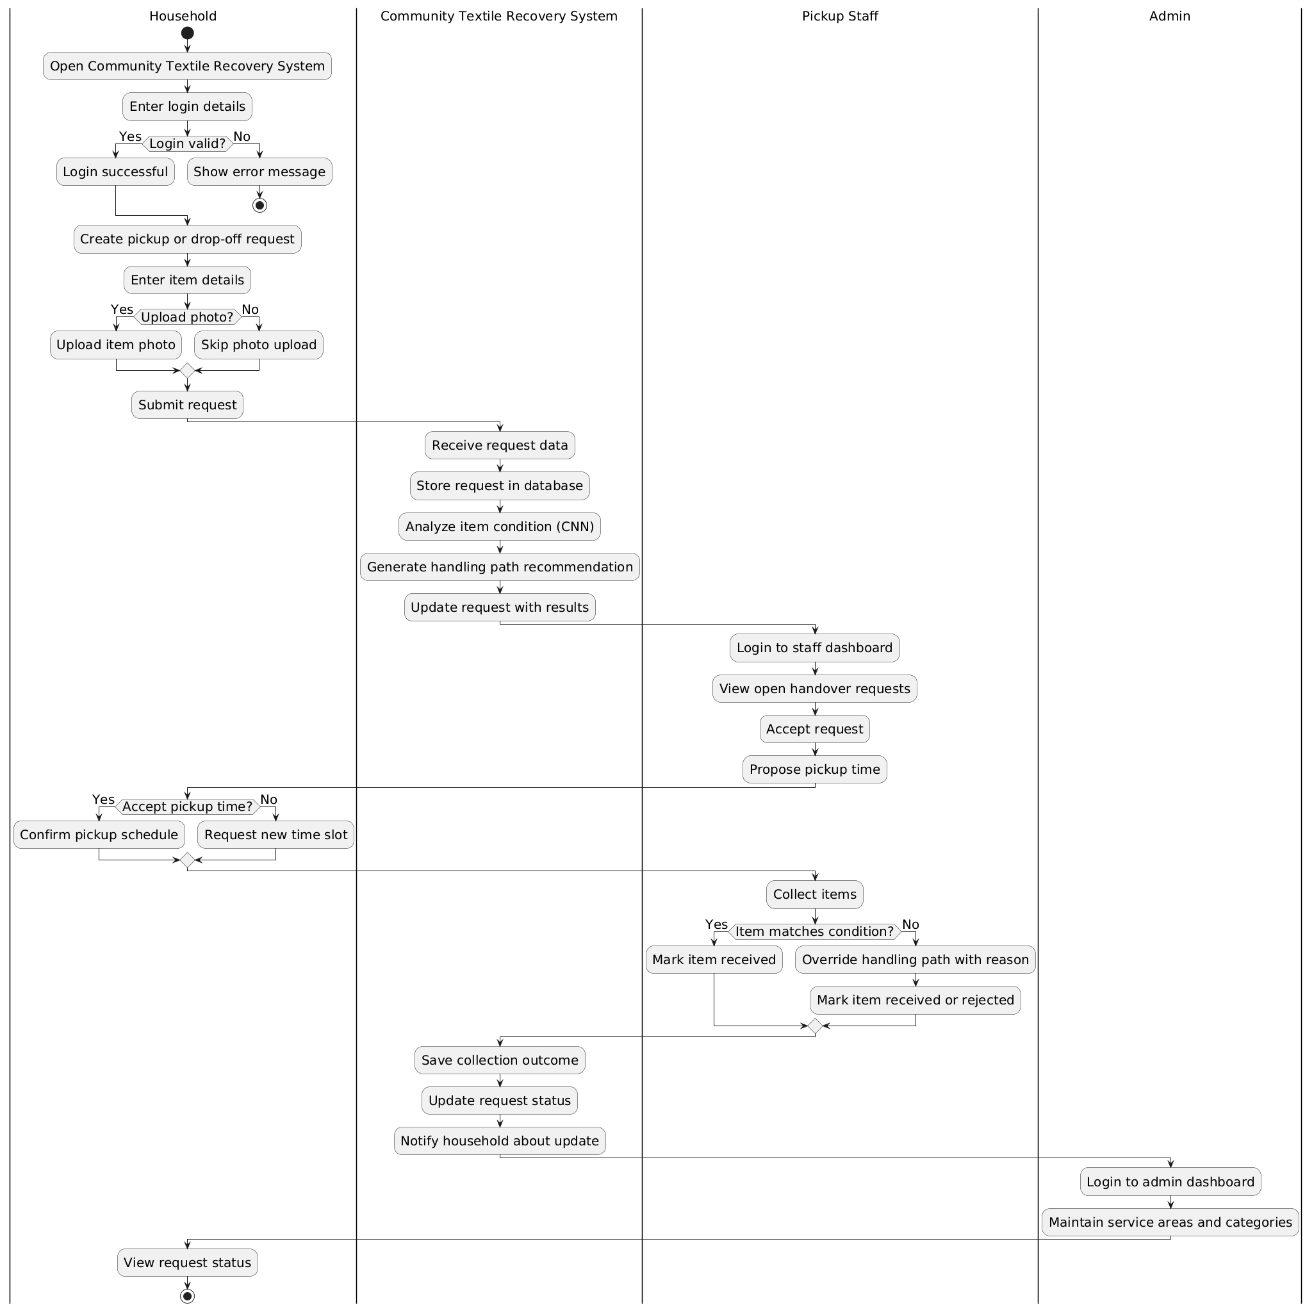
Figure.2 Activity Diagram

